MODULE 1
VALUE EDUCATION

Introduction:

All human beings aspire for a happy, fulfilling life. For a human being, there are two important questions pertaining to this:
What is my aspiration? (What to do?)
How to fulfill my aspiration? (How to do?)

The purpose of education is to facilitate the development of clarity on the aspiration and adequate competence to actualize it.

We are doing something because we want to become something, so that we can get something; and this doing, becoming and getting is in order to be something, which is ‘happy and prosperous’. That something basic is what we want to be; and what we want to continue to be. ‘To be happy and prosperous – in continuity’ is our basic aspiration.

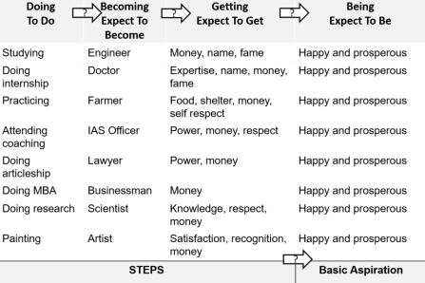

Understanding human aspiration, or what is really valuable for human being, is the value domain. The subject which enables us to understand this domain is called ‘Value Education’ (VE). Character oriented education that instills basic values and ethnic value in one’s psyche is called ‘Value Based Education’. It enables us to understand our aspirations and visualize our goals for a fulfilling life and indicates the direction for their fulfillment. In relation to these issues, it also helps to remove our confusions and contradictions. In that sense, VE addresses the issues related to 'what to do?

It is also necessary to learn the skills to actualize our aspirations. This is the skill domain. The subject which enables us to learn the skills is called 'Skill Development' (SD). It enables us to learn the science, technology, management and other skills for fulfilling our aspiration. In that sense, SD addresses the issues related to "how to do?".

Values and skills go hand in hand. Both values and skills are required. There is an essential complementarily between the two. The priority is values, then skills; i.e. first understanding 'what to do' and then developing the skills for 'how to do. And of course, checking if this results into a fulfilling life!
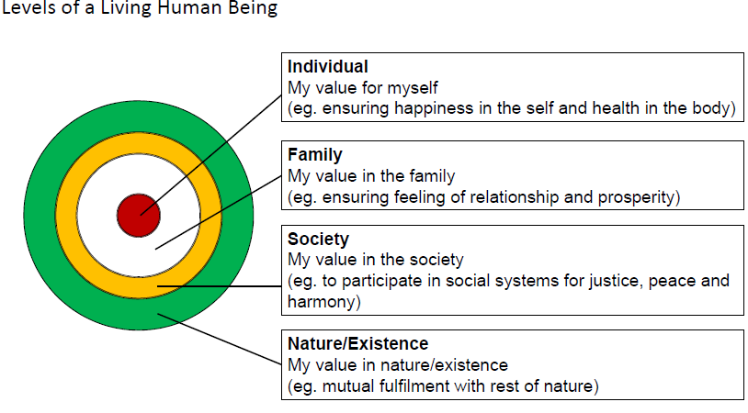
Living in Myself : We all have desires, thoughts, beliefs, imaginations and choices. This is the first level of our living. Before expressing ourselves in relations, we think, and whatever we receive from the other, it again passes through our internal processes. We refer to this as (our) Self. This inner world (or ‘myself ’) co-exists with the body and together we refer to this as a ‘human being’.
Living in Family: All of us are born to our parents and this is the family we are born to. This is the first web of relationships for each one of us and subsequently we live in more relationships that include our siblings, our friends and classmates, teachers and others. These are the people we live with on a daily basis, and we call this ‘family’.
Living in Society: Our family is part of a larger group of people we live with where there are interdependencies around food, clothing, housing, services, health, education, justice etc. We live as a part of this human system. This is our society.
Living in Nature/Existence: We are on this earth: with the grass, plants and trees, birds, animals and other humans surrounding us and we live in this large eco-system that we call nature. Regardless of where we are, our village, town or city, is within this eco-system or natural habitat. Our planet is surrounded by a larger system of planetary bodies and that includes the moon, the sun and the infinite stars and planetary systems that surround us. Our earth is a part of the solar system that co-exists with all that there is in this entire ‘existence’. And then there is space between planets, even between you and the book right now! All these things present in space are together called as existence. ‘Existence’ means all that exists.

Meaning of Value Education:
Value Education is the education which enables to understand ‘what is valuable’ for human happiness. It is all about enabling a transformation in the human beings to help them move from Animal Consciousness to Human Consciousness.

Need for Value Education:

- Correct identification of our aspirations: The subject which enables us to understand ‘what is valuable’ for human happiness is called ‘value education’ (VE). Thus, VE enables us to understand our needs and visualize our goals correctly and also indicate the direction for their fulfillment. It also helps to remove our confusions and contradictions and bring harmony at all levels.

- Understanding universal human values to fulfill our aspirations in continuity: Values form the basis for all our thoughts, behaviors and actions. Once we know what is valuable to us, these values becomes the basis, the anchor for our actions. We also need to understand the universality of various human values, because only then we can have a definite and common program for value education. Then only we can be assured of a happy and harmonious human society.

- Complimentarily of values and skills: To fulfill our aspirations both values and skills are necessary. When we identify and set the right goals and produced in right direction. This is known as value domain, the domain of wisdom, and when we learn and practices to actualize this goal to develop the techniques to make this happen in real life, in various dimensions of human Endeavour (struggle). This is known as domain of skills. Hence, there is an essential complementarily between values and skills for the success of any human Endeavour.
For example, I want to lead a healthy life. Only wishing for good health will not help me keep my body fit and healthy and without having understood the meaning of health, I will not be able to choose things correctly to keep my body fit and healthy.

- Evaluation of our beliefs: Each one of us believes in certain things and we base our values on these beliefs, are they false or true which may or may not be true in reality. These believes come to us from what we read, see, hear, what our parents tells us, our friends talk about, what them magazines talk of, what we see from TV etc. Value Education helps us to evaluate our beliefs and assumed values.

- Technology and human values: The present education system has become largely skill-based. The prime emphasis is on science and technology. However, science and technology can only help to provide the means to achieve what is considered valuable. It is not within the scope of science and technology to provide the competence of deciding what really is valuable. Value Education is a crucial missing link in the present education system. Because of this deficiency, most of our efforts may prove to be counterproductive and serious crises at the individual, societal and environmental level are manifesting.

Basic Guidelines for Value Education

The Basic guidelines of Value Education course are as follows:
- Universal: It needs to be applicable to all the human beings irrespective of cast, creed, nationalities, religion, etc., for all times and regions.
- Rational: It has to appeal to human reasoning. It has to be amenable to reasoning and not based on dogmas or blind beliefs.
- Natural and verifiable: It has to be naturally acceptable to the human being who goes through the course and when we live on the basis of such values it leads to our happiness. It needs to be experientially verifiable, and not based on dogmas, beliefs or assumptions.
- All encompassing: Value education is aimed at transforming our consciousness and living. Hence, it needs to cover all the dimensions (thought, behavior, work and realization) and levels (individual, family, society, nature and existence) of human life and profession.
- Leading to harmony: The value education ultimately is targeted to promote harmony within the individual, among human beings and with nature.

Content of Value Education

The value of an entity is its participation in the larger order of which unit a part. The contest is always the larger order. Value has to do with the participation of a unit in the larger order. Eg: A Piece of chalk is a unit. The classroom is the larger order for this unit. The value of chalk is that it can be used to write on the blackboard for the desired functioning of the classroom.

The value or role of a human being is its participation in the larger order. This Value is worth understanding, worth thinking about, worth living. The value of human being is to ensure mutual fulfillment in the larger order', ie, in the entire nature existence, but starting from within themselves, then extending in their family and in the society.

Hence, understand human values, we need to study the human reality along with all that there in entire nature/existence which constitutes the larger order. We need to explore and understand things we are able to recognize and fulfill our participation with them.

That means the content or scope of study his to be all encompassing i.e
- It has to cover all dimensions of human being- thought, behavior, work and realization.
- It has to cover all levels of human living individual, family, society, nature and existence..

The content of value education will be to understand myself, my aspirations, my happiness; understand the goal of human life comprehensively, understand the other entities in nature, the innate inter-connectedness, the coexistence in the nature- existence and finally the role of human being in this nature/existence entirely.

Process of Value Education

Human Values can be understood by an appropriate process of self-discovery, because they are potentially there in each and every human being. There is already a natural acceptance for values in a human being. It is only that we have to discover them or become aware of them. Thus, the process of Value Education has to be that of self-exploration, and not of giving sermons or telling dos & don'ts Whatever is found a as truth or reality may be stated as a proposal and every student is to be encouraged to verify it on his/her own right.

You can check if you want to be able to decide on your owes right or you want somebody else to decide for you? This somebody may be a group of people, it may be the society of the education system, etc. If you are not able to decide o your own right then
- Someone else is programming you u (deciding what is valuable and what is not valuable for you)
- Unconsciously you keep accepting those things as values
- You get busy with how to implement them, how to realise them and materialize them
This process of self-exploration has to be in the form of a dialogue between "what I am" and "what I really want to be', which is the natural acceptance

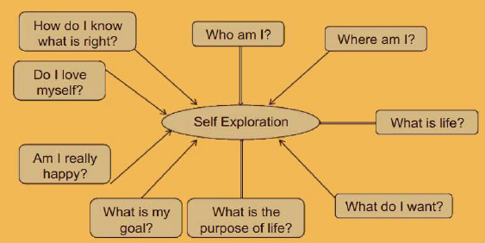

Human Values

Meaning and definition of Human Values: Human values are closely related with human life. No human life is possible without values. Human Values are those universal concepts, drivers of action which are found in all cultures, all societies, all times and in all places where human beings take out their lives. Human values are a set of consistent behaviors and measures that guide human beings in doing what is right and acceptable by the society.

The five human values, which can be found in all cultures, all societies and in all religions, are

- TRUTH: Learning to speak the truth is a first and vital step in the formation of strong character. Telling lies hurts ourselves as well as others in a subtle, but very real way.

- RIGHT CONDUCT: Every action is preceded by a thought. If the thought is consciously seen and noted, it aims to assist and is unselfish, the action will be good for oneself and others.

- PEACE: Freedom from disturbance. When there is peace in the individual, there will be peace in family, when there is peace in the family, there will be peace in the community.

- NON-VIOLENCE: Nonviolence is the personal practice of being harmless to self and others under every condition. It comes from the belief that hurting people, animals or the environment is unnecessary to achieve an outcome.

- LOVE: Love is not an emotion, affected by the subconscious mind, but is a pure reaction from the heart. • It is power of love which causes one person to wish happiness for another and take pleasure in their well-being. • “It is giving and unselfish”.
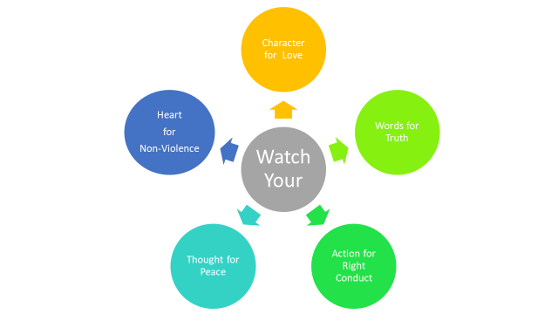

Self-Exploration

Meaning and definition: Self exploration is the process to find out what is valuable to me by investigating within myself, what is right for me, true for me, has to be judged within myself. Through self-exploration we get the value of ourselves. We live with different entirety (family, friends, air, soil, water, trees, etc.) and we want to understand our relationship with all these.

Content of Self-exploration: The main focus of self-exploration is myself - the human being. Content of self-exploration is just finding answers to the following fundamental questions of all human beings:
A.) The Desire/Goal:
- What is my (human) Desire/ Goal?
- What do I really want in life, or what is the goal of human life?
B.) Program:
- What is my (human) program for fulfilling the desire?
- How to fulfill it?

Purpose of Self-exploration:

1. It is a process of dialogue between “what you are” and “what you really want to be”:
We will look into ourselves and find out what we are today, and how this contrasts from what we really want to be. If these two are the same, then there is no problem. If on investigation we find that these two are not the same, then it means we are living with this contradiction (of not being what we really want to be) and hence, we need to resolve this contradiction, this conflict within us.
2. It is a process of self evolution through self-investigation:
By self-investigation, we shall work towards being what we really want to be. Hence, the self-exploration leads to our own improvement, our own self-evolution – we will become qualitatively better. We can be more in harmony within ourselves.
3. It is a process of knowing oneself and through that, knowing the entire existence:
Thus, self-exploration leads to us knowing ourselves better. Today, we are largely unaware of our own characteristics, our own assumptions, beliefs and pre-conditionings. We will go beyond these beliefs to know ourselves. Once we have known ourselves, and we are sure of it, we can then also know all the things around us correctly. This way, we can be sure of these things in our own right, we can be authentic about them. We don’t have to continue to live merely with assumptions about these things.

4. It is a process of recognizing one’s relationship with every unit in existence and fulfilling it:
Once we start knowing ourselves and everything beside us, we shall understand our relationship with them i.e. we shall understand our relationship with other humans, animals, plants and matter etc. We shall then know how we have to live in harmony with all these things.
5. It is a process of knowing human conduct, human character and living accordingly:
None of us wants to live with uncertainty. If our state of mind, our own behaviour keeps changing, we are not comfortable with ourselves. We all desire for certainty and stability. Once we know our own true nature, we will also understand what is our participation with the other things we live with – this is the ethical human conduct or the humane conduct. This is what characterizes a human being. When we know this true human character, we start moving towards it in a natural manner.
6. It is a process of being in harmony with oneself and in harmony with entire existence:
Through the process of Self-exploration, I establish a dialogue with my natural acceptance. This enables me to be in harmony within myself. Through the same process, I am able to explore into the harmony in the entire existence. We slowly come to realize (and we will keep talking about this in the entire book) that there is an innate harmony in the existence. I only need to discover this. And once I do this, I can learn to live in harmony with the entire existence. Thus the process of Self-exploration helps me live in harmony within myself and in all my interactions with the world around.

Process of Self-Exploration

For self-exploration we need two expects:
- Natural acceptance: Natural acceptance implies unconditional and total acceptance of the self, people and environment. It also refers to the absence of any exception from others. Once we fully and truly commit ourselves on the basis of natural acceptance, we feel a holistic sense of inner harmony, tranquility and fulfillment.
Natural Acceptance(Svatva): It is the process of seeing and observing everything and then using your inner conscience to get the answer from within. It is a way to bring out the goodness in everything naturally. It helps us to learn everything that is good from others and absorb it in our own way, but without changing our identity. Alternatively, Natural acceptance implies unconditional and total acceptance of the self, people and environment. It also refers to the absence of any exception from others. In other words, Natural acceptance is way to accept the good things naturally.

Characteristics of Natural Acceptance:

It does not change with time/age: What is naturally acceptable to you today is the same as what was naturally acceptable to you yesterday, and what will be naturally acceptable to you tomorrow. For example, our natural acceptance for the feeling of trust, for the feeling of respect in relationship remains invariant with time: a child naturally accepts having the feeling of trust. Twenty years later, when (s)he becomes a youth, she still has a natural acceptance for trust; and when she grows into an old person, (s)he continues to have a natural acceptance for the feeling of trust – there is no change in the natural acceptance with time for any given person.

It doesn’t depend on place: Naturally acceptable feelings, like trust, respect, affection, etc. remain invariant with place. These feelings are naturally acceptable to me when I am in India, in America, in Africa, in Europe or in any other place. Like that, my natural acceptance to keep the Body healthy does not change with place. No matter where we are, we have the same natural acceptance at all the places.

Natural acceptance is uncorrupted by likes and dislikes or assumptions or beliefs: We have taken the examples of this above also. When we ask the right questions, we can see our natural acceptance and it is there. Natural acceptance remains unaffected by our likes and dislikes, our belief systems and our preconditioning even if they are very deep and influence our thoughts day and night. For example, even if we are preconditioned for years ‘not to trust anyone’, if we ask the question as to what is naturally acceptable ‘trust or mistrust’, the answer is in favor of trust.

Natural acceptance is innate; we don’t need to create it: Whatever be the background of a person, this faculty is very much there. For example, the moment we think of disrespecting someone, how does it feel within? Comfortable or uncomfortable? Similarly, the moment we think of opposing anyone, how does it feel? Are we at ease or we feel uneasy? Of course, uneasy. Why is this happening? Because we have the faculty of natural acceptance as a part and parcel of our being and it keeps hinting that what we are feeling, thinking or doing is in harmony with our own natural acceptance or not. We can start referring to it at any time, it is always there.

Natural acceptance is definite: It is for relationship, harmony and co-existence which is universal. This we can directly verify by asking, what is naturally acceptable to us – relationship or opposition, harmony or disharmony, co-existence or struggle? When we look into the details of relationship, harmony and co-existence, in chapters to follow, we will ask these questions again regarding each and see that these three – relationship, harmony and coexistence, ultimately provide the guidance for our living in harmony, happiness.

- Experiential validation: Experiential validation is a process that infuses direct experience with the learning environment and content. It may be regarded as a philosophy and methodology in which the direct experience and focused reflection of the individual helps to increase knowledge, develop skill and clarify values.

“Self-exploration takes place in the self and not the body”.

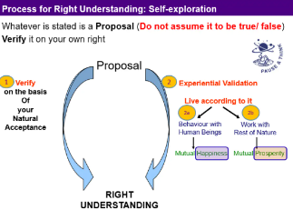

Self-exploration helps us to identify our
- Swatva: Innateness of self – the natural acceptance of harmony
- Swatantrata: Being self- organized – being in harmony with oneself
- Swarajya: Self-expression, self- extension – living in harmony with others

Continuous Happiness and Prosperity- A look at basic human aspirations

Happiness: Happiness may be defined as being in harmony/synergy in the state/ situation that I live in. i.e., “A state or situation in which I live, if there is harmony in it then I like to be in that state/situation. The state of liking is happiness.”
Happiness is a state of mind or feeling characterized by contentment, love, satisfaction, pleasure or joy. Happiness may be described as consisting of positive emotions and positive activities.
There may be three kinds of happiness:
- Pleasure and Gratification.
- Embodiment of Strengths and Virtues.
- Meaning and Purpose.
Happiness is the state of mind, where we feel good in most of the walk of life.

Prosperity: The feeling of having or making available more than required physical facilities is prosperity. For prosperity, two things are required-
- Identification of the required quantity of physical facilities, and
- Ensuring availability / production of more than required physical facilities.
We can be prosperous only if there is a limit to the need for physical facilities. If there is no limit what so ever be the availability the feeling of prosperity cannot be assured.

We are trying to achieve happiness and prosperity by maximizing accumulation and consumption of physical facilities. It is becoming anti-ecological and anti-people, and threatening the human survival itself. Some of the consequences of such trend are summarized below:
At the level of individual – rising problems of depression, psychological disorders, suicides, stress, insecurity, etc.
At the level of family – breaking of joint families, mistrust, and conflict between older and younger generations, insecurity in relationships, divorce, dowry tortures, etc.
At the level of society – growing incidence of terrorism and naxalism, rising communalism, spreading casteism, racial and ethnic struggle, wars between nations, etc.
At the level of nature – global warming, water, air, soil, noise pollution, etc. Resource depletion of minerals and mineral oils, etc.
All the problems are a direct outcome of an incorrect understanding, our wrong notion about happiness and prosperity and their continuity – this is an issue for serious exploration.

- SVDD: Sadhan Viheen Dukhi Daridra – Materially Deficient, Unhappy and Deprived.
Those that do not have physical facilities/ wealth and feel unhappy and deprived.
2. SSDD: Sadhan Sampann Dukhi Daridra: Those that have physical facilities/ wealth and feel unhappy and deprived. i.e. – Materially Affluent, Unhappy and Deprived. But these are states we don’t want to be in. We want to move from this to third category i.e.
3. SSSS: Sadhan Sampann Sukhi Samriddha: Having physical facilities and feeling happy and prosperous i.e – Materially Adequate, Happy and Prosperous.
Presently, as we look around, we find most of the people in the above two categories called SVD and SSDD, while the natural acceptance of all human beings is to be in the category of SSSS.

Right understanding, Relationship and Physical Facility

The basic requirements for fulfillment of aspirations of every human being
Three things needed to fulfill basic human aspirations: Our basic aspirations are happiness (mutual fulfilment) and prosperity (mutual prosperity). Happiness is ensured by the relationships with other human beings and prosperity is ensured by working on physical facilities.

- Right Understanding: This refers to higher order human skills – the need to learn and utilize our intelligence most effectively.
- Good Relationships: This refers to the interpersonal relationships that a person builds in his or her life – at home, at the workplace and in society.
- Physical Facilities: This includes the physiological needs of individuals and indicates the necessities as well as the comforts of life. It means the feeling of having or being able to have more physical facilities than is needed.
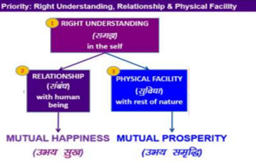

In order to resolve the issues in human relationships, we need to understand them first, and this would come from ‘right understanding of relationship’. Similarly in order to be prosperous and to enrich nature, we need to have the ‘right understanding’. The ‘right understanding’ will enable us to work out our requirements for physical facilities and hence correctly distinguish the difference between wealth and prosperity. With nature as well, we need to understand the harmony in nature, and how we can complement this harmony.

Understanding Happiness and Prosperity correctly: A critical appraisal of the current scenario

Transformation from Animal Consciousness to Human Consciousness: Giving all priorities to physical facilities only, or to live solely on the basis of physical facilities, may be termed as ‘Animal Consciousness’. Living with all three: Right understanding, Relationship and Physical facilities is called ‘Human Consciousness’.
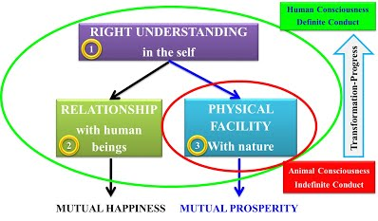
From the diagram we can say that:
• For animal, physical facility is necessary as well as complete – whereas for human beings it is necessary but not complete.
• Working only for physical facilities is living with Animal Consciousness.
• Working for right understanding as the first priority followed by relationship and physical facilities implies living with Human Consciousness.
• There is a need for transformation from Animal Consciousness to Human Consciousness. It can be accomplished only by working for right understanding as the first priority.
• This transformation from Animal Consciousness to Human Consciousness forms the basis for human values and values based living.
The content of education is the understanding of harmony at all the four levels of our existence –from myself to the entire existence. Right living or sanskar refers to the ability to live in harmony at all the four levels of living. This dimension of society works to ensure ‘right understanding’ and ‘right feelings’ in individual. Or all-encompassing solution called samadhan in every individual and ensures that our succeeding generation have both the content and the environment available to work towards achieving their goal of continuous happiness and prosperity.

Method to fulfill the human aspirations: understanding and living in harmony at various levels.

We can understand Happiness as: “ to be in state of liking is happiness.” and “ the situation in which I live, if there is harmony in it, then I like to be in that state or situation”. Continuous happiness is being in harmony within one self, being in harmony with others and being harmony with nature. The three basic requirements to ensure happiness and prosperity for human beings are –
i. Right Understanding ii. Relationships iii. Physical Facilities
In the modern times, we are mostly not paying attention to (i) and (ii) and are focusing largely on (iii) most of the time. As human beings, all the three are needed for us.

Importance/ Need for Right Understanding: Right Understanding helps to create harmony at all four levels of human living. Right Understanding enables us to –
- Resolve the issues in human relationships
- Be prosperous
- Enrich Nature
- Work out our requirements for physical facilities
- Correctly distinguish between wealth and prosperity
- Understand the harmony in Nature
- Right Understanding forms the basis on which we can work for relationships and also acquire Physical Facilities.

Living with wrong assumptions (Our state today): Today, if we look into it, we can see that this levels of living are full of conflicts, opposition and contradictions. We are unable to be at peace with ourselves. Most of the time, we are under stress unhappy about something or the other, and are worrying about things. We are increasingly having more diseases, are unable to live properly in relationships in the family and are disturbing and destroying the very planet we live on. In short we are unable to live harmoniously in every aspect of our living

Living in Harmony at all levels of living with the help of Right Understanding:

1. At the level of Myself: Self-Exploration with the help of Natural Acceptance and Experiential Validation helps to develop a sense of Right Understanding. This right understanding helps me to understand myself clearly, and helps me to develop a feeling of Satisfaction, Prosperity and Happiness(Harmony) in Myself.
2. At the level of Family: Right understanding helps me to understand others feelings and expectations in a better way. This ensures harmony in family.
3. At the level of Society: Our family is a part of a large group of people called the Society. As we understand our relationships with others in our family, we also start understanding others in the society and can maintain fulfilling relations with everyone.
4. At the level of Nature/ Existence: We live in a large eco-system called Nature. Existence refers to all the things that exist in Nature. Once we learn to maintain harmony with the society, we also develop a feeling of concern towards the plants, trees, animals etc. in Nature. Hence right understanding leads to mutual fulfilment with Nature.

2 MARKS QUESTIONS

- What do you mean by UHV?
Universal human values are the ethical principles that transcend cultural, religious, and geographical boundaries, serving as the moral compass guiding human behavior. These values, shared by people of diverse backgrounds, promote harmony, empathy, and cooperation in our global society. By embracing universal human values, societies can overcome divisions and conflicts. These values are not imposed but emerge from our shared human experiences, reflecting the innate desire for peace and happiness. They transcend borders and belief systems, uniting us in our pursuit of a better world.

- List out any four persons who are ethical in India.
- Mahatma Gandhi, the embodiment of nonviolence (1869-1948): One of the great personalities of India, led the triumphant march to freedom, guided by the sacred principles of non-violence, civil disobedience, and Satyagraha. Fondly called Bapu, his unwavering commitment to justice and peace continues to inspire generations, cementing his position as the Father of the Nation. His remarkable legacy stands as an indomitable symbol of unity and resilience, leaving an enduring impact on the annals of history.
- Rabindranath Tagore – The Artistic Visionary (1861-1941): Rabindranath Tagore, one of the great personalities of India, an eminent Renaissance man, donned the hats of poet, philosopher, musician, and artist with unparalleled finesse. As the first Asian Nobel laureate in Literature, Tagore’s immortal verses in “Gitanjali” have touched souls worldwide, delving into the profundity of human emotions and the resplendence of nature. His indelible legacy continues to thrive through Visva-Bharati, the educational institution he founded.
- Dr. APJ Abdul Kalam – The Architect of Innovation (1931-2015): A true trailblazer in the realm of science and the 11th President of India, Dr. APJ Abdul Kalam, fondly remembered as the Missile Man charted India’s momentous journey into space exploration and missile technology. His unwavering vision for a technologically advanced India and his role as a mentor to budding scientists continue to ignite the nation’s dreams of a brighter and more promising future.
- Sardar Vallabhbhai Patel – The Unifier of India (1875-1950): Fondly known as the Iron Man of India, Sardar Vallabhbhai Patel exemplified unwavering determination and strong leadership. His role in India’s fight for independence and in uniting the nation after gaining freedom was pivotal. Serving as India’s first Deputy Prime Minister and Home Minister, Sardar Patel skillfully integrated more than 500 princely states into the Indian Union, ensuring a united and powerful nation. His vision and efforts garnered immense respect and admiration both at home and abroad. Today, he stands as an enduring symbol of national unity and racial harmony, one of the famous personalities of India inspiring generations with his remarkable leadership and indomitable spirit.
- Sachin Tendulkar – The Cricketing Legend: A number of illustrious individuals have studied in the best schools in Mumbai and are now shining as beacons whose legacies endure worldwide.Sachin Tendulkar hailed as the peerless Master Blaster and the revered God of Cricket, wove an unbreakable tapestry of unity between the nation and its cherished sport. His unrivalled records and mastery on the cricket field not only ignited aspirations among aspiring cricketers but also forged an Indian inspirational personality’s indomitable sense of national pride.
- Indira Gandhi – The Steel-Willed Stateswoman (1917-1984): India’s first and only female Prime Minister, Indira Gandhi, exemplified fortitude and tenacity during her distinguished tenure. Her astute leadership during the Bangladesh Liberation War and her pivotal contributions to the Green Revolution earned both acclaim and critique. Nevertheless, her enduring legacy persists as a pioneering and resolute figure in Indian politics.
- Dr. Verghese Kurien – The Dairy Visionary (1921-2012): Dr. Verghese Kurien, affectionately hailed as the Milkman of India, revolutionised the dairy sector, empowering countless farmers and establishing the iconic Amul brand. His unwavering commitment to rural development and independence endures as a testament to success and wealth and a great personalities of India
- Swami Vivekananda, The Spiritual Luminary (1863–1902): Indian spirituality and philosophy were spread around the world thanks to Swami Vivekananda, a revered philosopher and spiritual torchbearer. At the Parliament of the World’s Religions in Chicago in 1893, he gave a stirring address that introduced the ideas of Vedanta and the idea of global brotherhood to a sizable audience.
- Rani Lakshmibai – The Warrior Queen (1828-1858): Rani Lakshmibai, the valorous Queen of Jhansi, emerged as a poignant symbol of defiance and courage during the Indian Rebellion of 1857. Her dauntless leadership and sacrifice on the battlefield have etched her name in the annals of Indian history, serving as an unwavering inspiration to generations of freedom fighters.
- Homi J. Bhabha – The Father of Indian Nuclear Program (1909-1966): Dr. Homi J. Bhabha, the pioneering nuclear physicist, played a crucial role in establishing India’s formidable nuclear program. His groundbreaking contributions in the field of nuclear science laid the foundation for India’s quest for energy independence and remarkable technological advancements.
- Lata Mangeshkar, The Indian Nightingale: Lata Mangeshkar, the revered Nightingale of India, has enchanted music aficionados for decades with her ethereal and soul-stirring voice. Her mellifluous renditions have not only resonated with the hearts of millions but also enriched India’s cultural heritage with unmatched brilliance making her one of famous personalities of India
- Mary Kom – The Magnificent Pugilist: Mary Kom, the renowned and accomplished boxer, has overcome all obstacles to rank among India’s most decorated athletes. She is the epitome of tenacity and grit thanks to her unwavering commitment and great talent, which have brought her several honours, including Olympic and World Championship gold.
- J.R.D. Tata – The Architect of Industrial Empowerment (1904-1993): The brilliant businessman J.R.D. Tata was instrumental in forming India’s expanding industrial environment. Under his competent direction, the Tata Group broadened its horizons into a variety of industries, including steel, aviation, and technology, making a lasting mark on the development and expansion of the country’s economy.
- Raja Rammohun Roy – The Pioneer of Enlightened Reforms (1772-1833): Raja Rammohun Roy, a sagacious social reformer and intellectual luminary, ardently challenged regressive practices prevalent in Indian society during the 19th century. His tireless efforts in eradicating the practice of sati (self-immolation of widows) and advocating for women’s rights and education became pivotal milestones in India’s reform movement.
- What is Value Education?
Understanding human aspiration, or what is really valuable for human being, is the value domain. The subject which enables us to understand this domain is called ‘Value Education’ (VE). Character oriented education that instills basic values and ethnic value in one’s psyche is called ‘Value Based Education’. It enables us to understand our aspirations and visualize our goals for a fulfilling life and indicates the direction for their fulfillment. In relation to these issues, it also helps to remove our confusions and contradictions. In that sense, VE addresses the issues related to 'what to do?

- What is Harmony?
Harmony is usually identified as a human value, referring to compatibility and accord in feelings, actions, relationships, opinions, interests, etc. It denotes a state of balance among force influencing and even opposing one another.

- What do you understand by Self-Exploration?
Self exploration is the process to find out what is valuable to me by investigating within myself, what is right for me, true for me, has to be judged within myself. Through self-exploration we get the value of ourselves. We live with different entirety (family, friends, air, soil, water, trees, etc.) and we want to understand our relationship with all these.
According to Merriam-Webster: -“The examination and analysis of one's own unrealized spiritual or intellectual capacities.’’

- What is meant by Natural acceptance?
Natural acceptance implies unconditional and total acceptance of the self, people and environment. It also refers to the absence of any exception from others. Once we fully and truly commit ourselves on the basis of natural acceptance, we feel a holistic sense of inner harmony, tranquility and fulfillment.

- Write features of Natural Acceptance?
Natural acceptance implies unconditional and total acceptance of the self, people and environment. It also refers to the absence of any exception from others. Once we fully and truly commit ourself on the basis of natural acceptance, we feel a holistic sense of inner harmony, tranquillity and fulfilment. Actually natural acceptance is way to accept the good things naturally. Learn everything that is good from others, but bring it in, and in our own way absorb it; do not become others. We can easily verify proposals in the basis of characteristics of natural acceptance mentioned below:
  - Natural acceptance does not change with time. It remains invariant with time. For example our natural acceptance for trust and respect does not change with age.
  - It does not depend on the place. Whatever we have accepted, in our life, at any time of our age, does not change, even if we move from one place to another one.
  - It does not depend on our beliefs or past conditionings. No matter how deep our belief or past conditioning, as long as we ask ourselves the question sincerely, as long as we refer deep within ourselves, the answer will always be the same.
  - This natural acceptance is 'constantly there', something we can refer to. Natural acceptance is always there. Whatever we do, this natural acceptance is within us, it is telling us what is right.
  - Natural acceptance is the same for all of us: it is part and parcel of every human being, it is part of humanness. Though each one of us, may have different likes and dislikes and means to live and to react etc. but if we go deep in our mind the purpose of our work, behaviour, efforts etc. are based on common goals like need to be happy, need to be respected, need to get prosperity. So our basic acceptance remains the same.

- What is the difference between happiness and prosperity?

Happiness
The state or situation in which I live if there is harmony/synergy in it, then I like to be in that state or situation. i.e. to be in the state of liking is happiness.
Happiness is a state of mind or feeling characterized by contentment, love, satisfaction, pleasure or joy. A variety of biological, psychological, religious, and philosophical approaches have striven to define happiness and identify its sources. Happiness may be described as consisting of positive emotions and positive activities. There may be three kinds of happiness: pleasure, engagement, and meaning. In other words, freedom from want and distress, consciousness of the good order of things, assurance of one's place in the universe or society, inner peace and so forth. Happiness is the state of mind, where we feel good in most of the walk of life. Philosophers and religious thinkers often define happiness in terms of living a good life; or flourishing, rather than simply as an emotion.

Prosperity
Prosperity is the feeling of having or making available more than required physical facilities.
Prosperity is the state of flourishing, thriving, success or good fortune. Prosperity often encompasses wealth but also includes other factors which are independent of wealth to varying degrees, such as wisdom and health. The word means the sum of three aspects health, wealth and wisdom. Almost all of us feel that wealth alone means prosperity and try to explain this phenomenon on this non- existent or half fact. This is the state of enlightenment towards better life and happy society.

- What is meant by Experiential validation?
Experiential validation is a process that infuses direct experience with the learning environment and content. It may be regarded as a philosophy and methodology in which the direct experience and focused reflection of the individual helps to increase knowledge, develop skill and clarify values.

- Explain the consequences of Human life at various levels?
We are trying to achieve happiness and prosperity by maximizing accumulation and consumption of physical facilities. It is becoming anti-ecological and anti-people, and threatening the human survival itself. Some of the consequences of such trend are summarized below:
- At the level of individual - rising problems of depression, psychological disorders, suicides, stress, insecurity, etc.
- At the level of family - breaking of joint families, mistrust, and conflict between older and younger generations, insecurity in relationships, divorce, dowry tortures, etc.
- At the level of society - growing incidence of terrorism and naxalism, rising communalism, spreading casteism, racial and ethnic struggle, wars between nations, etc.
- At the level of nature - global warming, water, air, soil, noise etc. pollution, resource depletion of minerals and mineral oils, etc.
All the problems are a direct outcome of an incorrect understanding, our wrong notion about happiness and prosperity and their continuity - this is an issue for serious exploration.

